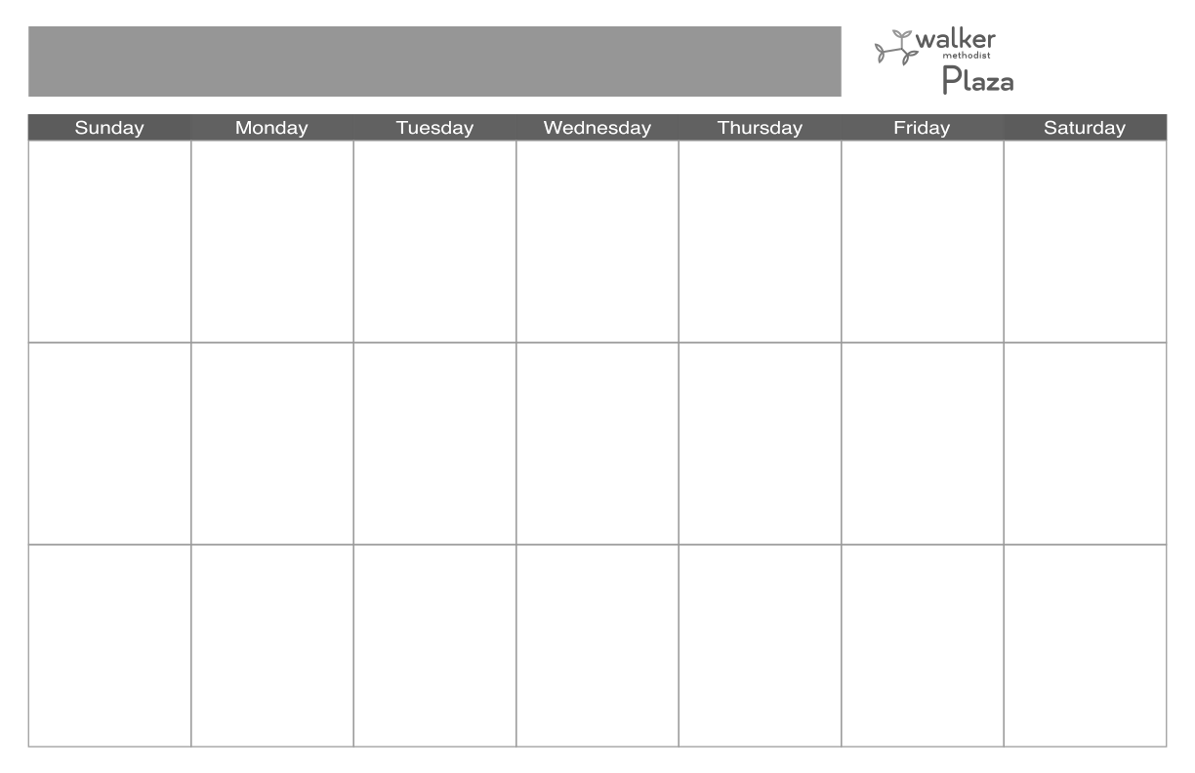 

**20**

**9:30 Mass (CH)**

**11:00 February Liturgical**

**Calendar ©**

**11:00 Better Balance (CR)**

**1:00 Movie Matinee:**

**5 People You Meet**

**in Heaven ©**

**1:30 Virtual Fitness (TV)**

**2:15 Aquafit/Open Swim**

**3:00 Cardio Drumming**

**(CR)**

**4:30 Rosary (CH)**

**7:00 Evening Social (CR)**

**7**

**1:00 500 (IL DR)**

**1:00 Bridge (IL DR)**

**12**

**9:30 Shopping at Cub**

**11:00 Protestant Service**

**(CH)**

**2:45 Happy Hour**

**(IL DR & CR)**

**4:30 Rosary (CH)**

**7:00 Bingo ($$) (CR)**

**10**

**10:00 Donuts &**

**Devotions (CR)**

**11:00 AL Mobile Activity**

**Cart**

**1:00 500 & Cribbage (CR)**

**1:15 AL Bingo (AL 3)**

**2:30 AL Fitness (AL 3)**

**2:30 Tenant Meeting**

**(CH)**

**3:15 Balloon Volleyball**

**with Kayvon (S)**

**4:30 Rosary (CH)**

**7:00 Bingo ($$) (CR)**

**11**

**9:30 Mass (CH)**

**10:00 AL Tenant Meeting**

**(AL 3)**

**11:00 Better Balance**

**(CR)**

**12:30 Bridge (IL DR)**

**1:30 Virtual Fitness**

**(TV)**

**1:30 Music with Pop**

**Standard Social**

**3:00 Card Bingo ($$)**

**(CR)**

**4:30 Rosary (CH)**

**17**

**10:00 Donuts &**

**Devotions (CR)**

**11:00 AL Mobile Activity**

**Cart**

**1:00 500 & Cribbage (CR)**

**1:00 Knitting with Sue**

**(IL DR)**

**1:15 AL Bingo (AL 3)**

**2:30 AL Fitness (AL 3)**

**3:15 Balloon Volleyball**

**with Kayvon (S)**

**4:30 Rosary (CH)**

**7:00 Bingo ($$) (CR)**

**3**

**10:00 Donuts &**

**Devotions (CR)**

**1:00 500 & Cribbage**

**(CR)**

**1:00 Knitting with Sue**

**(IL DR)**

**1:15 AL Bingo (AL 3)**

**2:30 AL Fitness (AL 3)**

**3:15 Balloon Volleyball**

**with Kayvon (S)**

**4:30 Rosary (CH)**

**7:00 Bingo ($$) (CR)**

**18**

**9:30 Mass (CH)**

**10:00 IL Culinary Meeting**

**(IL DR)**

**11:00 Better Balance**

**(CR)**

**12:30 Bridge (IL DR)**

**1:30 Virtual Fitness**

**(TV)**

**1:45 Music with Kristin**

**(AL 3)**

**3:00 Card Bingo ($$)**

**(CR)**

**4:30 Rosary (CH)**

**19**

**9:30 Shopping at Cub 11:00 Protestant Service**

**(CH)**

**1:30 January Birthday**

**Party with Rockin’**

**Woody (IL DR)**

**2:45 Happy Hour**

**(IL DR & CR)**

**4:30 Rosary (CH)**

**7:00 Bingo ($$) (CR)**

**16**

**9:45 Wii Bowling**

**11:00 Better Balance (CR)**

**12:30 Shopping at Target**

**1:00 Bridge (IL DR)**

**1:30 The Chosen Series**

**with John (C)**

**2:15 Aquafit/Open Swim**

**3:00 3rd Floor Social (CR)**

**4:30 Rosary (CH)**

**4:30 Tech Support (D)**

**13**

**9:30 Mass (CH)**

**11:00 Better Balance (CR)**

**1:00 Movie Matinee:**

**The Bucket List ©**

**1:30 Virtual Fitness (TV)**

**2:15 Aquafit/Open Swim**

**3:00 Cardio Drumming**

**(CR)**

**4:30 Rosary (CH)**

**January 2023 Independent & Assisted Living**

**8**

**10:30 Mass**

**(CH & 1-3)**

**1:00 Mexican Train**

**(2 CR)**

**1:00 500 (CR/TBD)**

**2**

**9:45 Wii Bowling**

**11:00 Better Balance (CR)**

**12:30 Shopping at Hy-Vee**

**1:00 Bridge (IL DR)**

**1:30 The Chosen Series**

**with John (C)**

**2:15 Aquafit/Open Swim**

**3:00 IL 1st Floor Social**

**(CR)**

**4:30 Rosary (CH)**

**4:30 Tech Support (D)**

**6**

**9:30 Mass & Adoration**

**(CH)**

**11:00 Better Balance (CR)**

**1:00 Movie Matinee:**

**Where the Crawdads**

**Sing ©**

**1:30 Virtual Fitness (TV)**

**2:15 Aquafit/Open Swim**

**3:00 Cardio Drumming**

**(CR)**

**4:30 Rosary (CH)**

**4**

**9:30 Mass (CH)**

**11:00 Better Balance**

**(CR)**

**11:00 Mobile Activity Cart**

**(AL)**

**12:30 Bridge (IL DR)**

**1:30 Virtual Fitness**

**(TV)**

**1:45 Music with Kristin**

**(AL 3)**

**3:00 Card Bingo ($$)**

**(CR)**

**4:30 Rosary (CH)**

**5**

**9:30 Shopping at Cub**

**11:00 Protestant Service**

**(CH)**

**1:30 Music with Les**

**Blake (IL DR)**

**2:45 Happy Hour**

**(IL DR & CR)**

**4:30 Rosary (CH)**

**7:00 Bingo ($$) (CR)**

**1**

**10:30 Mass**

**(CH & 1-3)**

**1:00 Mexican Train**

**(2 CR)**

**1:00 500 (CR/TBD)**

**15**

**10:30 Mass**

**(CH & 1-3)**

**1:00 Mexican Train**

**(2 CR)**

**1:00 500 (CR)**

**14**

**10:00 Men’s Coffee**

**(CR)**

**10:00 Women’s Coffee**

**(IL DR)**

**1:00 500 (CR)**

**1:00 Bridge (IL DR)**

**9**

**9:45 Wii Bowling**

**11:00 Better Balance (CR)**

**12:30 Shopping at Dollar**

**Tree**

**1:00 Bridge (IL DR)**

**1:30 The Chosen Series**

**with John (C)**

**2:15 Aquafit/Open Swim**

**3:00 2nd Floor Social (CR)**

**4:30 Rosary (CH)**

**21**

**9:30 Blood Pressure**

**Checks (D)**

**10:30 Writer’s**

**Workshop (CR)**

**1:00 500 (CR)**

**1:00 Bridge (IL DR)**

**7:00 Movie: As Good**

**As it Gets ©**

**24**

**10:00 Donuts &**

**Devotions (CR)**

**11:00 AL Mobile Activity**

**Cart**

**1:00 500 & Cribbage (CR)**

**1:15 AL Bingo (AL 3)**

**2:30 AL Fitness (AL 3)**

**3:15 Balloon Volleyball**

**with Kayvon (S)**

**4:30 Rosary (CH)**

**7:00 Bingo ($$) (CR)**

**27**

**9:30 Mass (CH)**

**11:00 Better Balance (CR)**

**1:00 Movie Matinee:**

**Field of Dreams ©**

**1:30 Virtual Fitness (TV)**

**2:15 Aquafit/Open Swim**

**4:30 Rosary (CH)**

**30**

**9:45 Wii Bowling (CR)**

**11:00 Better Balance (CR)**

**12:30 Shopping at Dollar**

**Tree**

**1:00 Bridge (IL DR)**

**1:30 The Chosen Series ©**

**2:15 Aquafit/Open**

**Swim (P)**

**3:00 Craft with Cindy:**

**Tie Dye Baseball**

**Hats (IL DR)**

**4:30 Rosary (CH)**

**31**

**9:00 Advanced Hearing**

**Care (B)**

**10:00 Donuts &**

**Devotions (CR)**

**11:00 AL Mobile Activity**

**Cart**

**1:00 500 & Cribbage (CR)**

**1:15 AL Bingo (AL 3)**

**2:30 AL Fitness (AL 3)**

**3:15 Balloon Volleyball**

**with Kayvon (S)**

**4:30 Rosary (CH)**

**7:00 Bingo ($$) (CR)**

**25**

**9:30 Mass (CH)**

**11:00 Better Balance**

**(CR)**

**12:30 Bridge (IL DR)**

**1:30 Virtual Fitness**

**(TV)**

**2:00 Back to the 50’s**

**with Robby Vee**

**(IL DR & CR)**

**4:30 Rosary (CH)**

**Program Locations**

**(AL 3) AL 3rd floor**

**Activity Room**

**(AL Lib) AL 2nd floor**

**Library**

**(B) Bistro**

**(C) Cinema**

**(CH) Chapel**

**(CR) Club Room**

**(2 CR) 2nd floor Club Room**

**(IL DR) IL Dining Room**

**(S) Studio**

**(P) Pool**

**$$ Notes**

**Card Bingo = 4 nickels, 4 dimes, 4 quarters, $1**

**7:00 Bingo = 10 dimes & 1 quarter**

**On TV**

**Channel 1-2: Activities**

**& daily notes**

**Channel 1-3: Services & Events in the Chapel**

**26**

**9:30 Shopping at Cub 11:00 Protestant Service**

**(CH)**

**1:30 Music with The**

**Somewhat Jazz**

**Band (IL DR)**

**2:45 Happy Hour**

**(IL DR & CR)**

**4:30 Rosary (CH)**

**7:00 Bingo ($$) (CR)**

**29**

**10:30 Mass**

**(CH & 1-3)**

**1:00 Mexican Train**

**(CR)**

**1:00 500 (CR)**

**23**

**9:45 Wii Bowling (CR)**

**11:00 Better Balance (CR)**

**1:00 Bridge (IL DR)**

**1:30 The Chosen Series ©**

**2:15 Aquafit/Open Swim**

**2:00 Book Club (AL 3)**

**4:30 Rosary (CH)**

**Please note all activities are subject to change. Please check daily posters located throughout the community for changes.**

**22**

**10:30 Mass**

**(CH & 1-3)**

**1:00 Mexican Train**

**(2 CR)**

**1:00 500 (CR)**

**Please sign up for activities at the Receptionist’s Desk as spaces are limited!**

**Fitness classes are highlighted in blue. If you have any questions, please call x7033.**

**28**

**10:00 Men’s Coffee**

**(CR)**

**10:00 Women’s Coffee**

**(IL DR)**

**1:00 500 (CR)**

**1:00 Bridge (IL DR)**

**January 2023 Independent & Assisted Living**