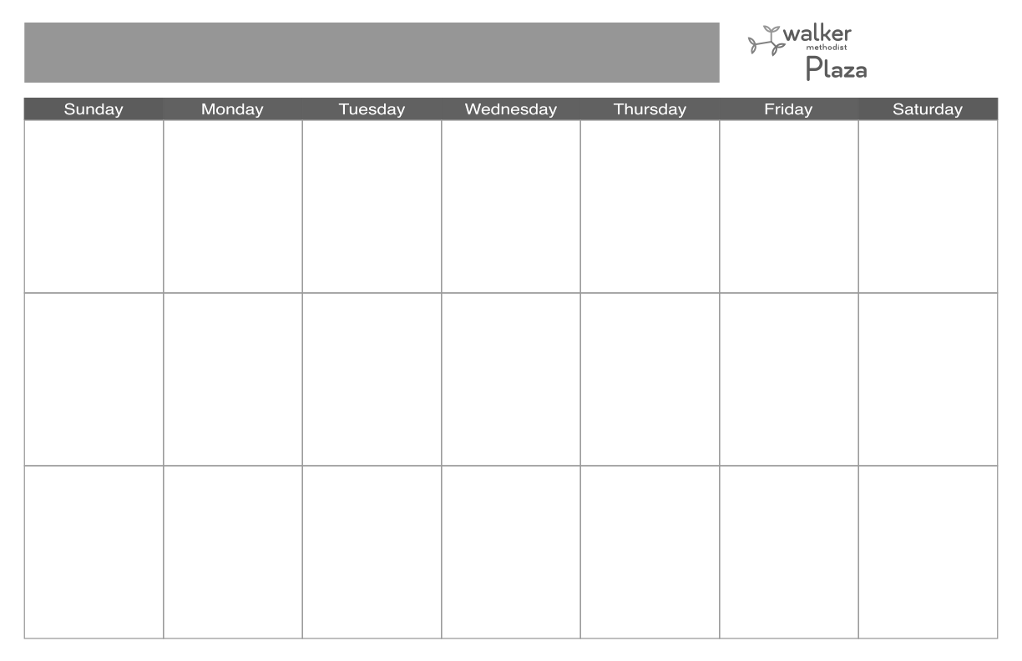::00t 

**10**

**8:00 Breakfast**

**10:00 Stretch & Volley**

**10:30 IN2L**

**12:00 Lunch**

**3:30 Sing-along**

**4:30 Rosary (TV 1-3)**

**18**

**8:00 Breakfast**

**9:30 Mass (TV 1-3)**

**10:15 Good Morning**

**Greetings**

**10:45 Music &**

**Movement**

**12:00 Lunch**

**3:30 Do You Hear What**

**I Hear?**

**4:30 Rosary (TV 1-3)**

**5:00 Dinner**

**11**

**8:00 Breakfast**

**9:30 Mass (TV 1-3)**

**10:15 Good Morning**

**Greetings**

**10:45 Armchair Travels**

**12:00 Lunch**

**1:00 Music with Kristin**

**4:30 Rosary (TV 1-3)**

**5:00 Dinner**

**9:30 Mass (TV 1-3)**

**10:15**

**10:45**

**12:00 Lunch**

**1:30**

**4:00 Mass (CH)**

**5:00 Dinner**

**16**

**8:00 Breakfast**

**10:00 Good Morning**

**Greetings**

**10:15 Cardio Drumming**

**12:00 Lunch**

**3:00 Crafternoon’s:**

**Fridge Magnets**

**4:30 Rosary (TV 1-3)**

**5:00 Dinner**

**4**

**8:00 Breakfast**

**9:30 Mass (TV 1-3)**

**10:15 Good Morning**

**Greetings**

**10:30 Armchair Travel**

**12:00 Lunch**

**3:30 Balloon Volley**

**4:30 Rosary (TV 1-3)**

**5:00 Dinner**

**1****9**

**8:00 Breakfast**

**10:00 Good Morning**

**Greeting**

**10:15 T is for Trivia**

**11:00 Protestant Service**

**(CH & TV 1-3)**

**12:00 Lunch**

**1:00 Fitness w/Emma**

**1:30 Music with Rockin**

**Woody**

**2:45 Happy Hour**

**4:30 Rosary (TV 1-3)**

**5:00 Dinner**

**20**

**8:00 Breakfast**

**9:30 Mass & Adoration**

**(CH)**

**10:15 Good Morning**

**Greetings**

**10:45 Reminisce: Andrew**

**Sisters**

**12:00 Lunch**

**3:00 IN2L**

**4:30 Rosary (CH)**

**5:00 Dinner**

**6**

**8:00 Breakfast**

**9:30 Mass & Adoration**

**(CH)**

**10:15 Good Morning**

**Greetings**

**10:45 Reminisce: Elvis**

**12:00 Lunch**

**3:00 IN2L**

**4:30 Rosary (CH)**

**5:00 Dinner**

**12**

**8:00 Breakfast**

**10:00 Good Morning**

**Greeting**

**10:15 T is for Trivia’**

**11:00 Protestant Service**

**(CH & TV 1-3)**

**12:00 Lunch**

**1:00 Fitness w/Emma**

**4:30 Rosary (TV 1-3)**

**5:00 Dinner**

**21**

**7**

**8**

**8:00 Breakfast**

**10:30 Mass (TV 1-3)**

**Communion**

**12:00 Lunch**

**3:30 Afternoon Snacks**

**with NAR’s**

**5:00 Dinner**

**5**

**8:00 Breakfast**

**10:00 Good Morning**

**Greeting**

**10:15 T is for Trivia**

**11:00 Protestant Service**

**(CH & TV 1-3)**

**12:00 Lunch**

**1:00 Fitness w/Emma**

**1:30 Music with Les**

**Blake (IL DR)**

**2:45 Happy Hour (CR)**

**4:30 Rosary (TV 1-3)**

**5:00 Dinner**

**2**

**8:00 Breakfast**

**10:00 Good Morning**

**Greetings**

**10:15 Cardio Drumming**

**12:00 Lunch**

**3:30 New Year’s Humor**

**& Snack**

**4:30 Rosary (TV 1-3)**

**5:00 Dinner**

**1**

**8:00 Breakfast**

**10:30 Mass (TV 1-3)**

**Communion**

**12:00 Lunch**

**3:30 Afternoon Snacks**

**with NAR’s**

**5:00 Dinner**

**13**

**8:00 Breakfast**

**9:30 Mass & Adoration**

**(CH)**

**10:15 Good Morning**

**Greetings**

**10:45 Reminisce: Judy**

**Garland**

**12:00 Lunch**

**3:00 IN2L**

**4:30 Rosary (CH)**

**5:00 Dinner**

**3**

**8:00 Breakfast**

**10:00 Stretch & Volley**

**10:30 IN2L**

**12:00 Lunch**

**3:30 Proper Sequence**

**4:30 Rosary (TV 1-3)**

**17**

**8:00 Breakfast**

**10:00 Stretch & Volley**

**10:30 IN2L**

**12:00 Lunch**

**3:30 Sing-along**

**4:30 Rosary (TV 1-3)**

**15**

**8:00 Breakfast**

**10:30 Mass (TV 1-3)**

**Communion**

**12:00 Lunch**

**3:30 Afternoon Snacks**

**with NAR’s**

**5:00 Dinner**

**14**

**9**

**8:00 Breakfast**

**10:00 Good Morning**

**Greetings**

**10:15 Cardio Drumming**

**12:00 Lunch**

**3:30 Reminisce: Music**

**with the Senses**

**4:30 Rosary (TV 1-3)**

**5:00 Dinner**

**January 2023 Care Suites Memory Care**

**31**

**8:00 Breakfast**

**10:00 Stretch & Volley**

**10:30 IN2L**

**12:00 Lunch**

**3:30 Sing-along**

**4:30 Rosary (TV 1-3)**

**8:00 Breakfast**

**9:30 Mass (TV 1-3)**

**10:15 Good Morning**

**Greetings**

**10:45 Music &**

**Movement**

**12:00 Lunch**

**1:00 Music with Kristin**

**3:00 Trivia**

**4:30 Rosary (TV 1-3)**

**5:00 Dinner**

**26**

**8:00 Breakfast**

**10:00 Good Morning**

**Greeting**

**10:15 T is for Trivia**

**11:00 Protestant Service**

**(CH & TV 1-3)**

**12:00 Lunch**

**1:30 Music with The**

**Somewhat Jazz**

**Band (IL DR)**

**2:45 Happy Hour**

**4:30 Rosary (TV 1-3)**

**5:00 Dinner**

**30**

**8:00 Breakfast**

**10:00 Good Morning**

**Greetings**

**10:15 Cardio Drumming**

**12:00 Lunch**

**3:30 Crafternoon’s:**

**Gems & Jewels**

**Suncatchers**

**4:30 Rosary (TV 1-3)**

**5:00 Dinner**

**29**

**8:00 Breakfast**

**10:30 Mass (TV 1-3)**

**Communion**

**12:00 Lunch**

**3:30 Afternoon Snacks**

**with NAR’s**

**5:00 Dinner**

**23**

**8:00 Breakfast**

**10:00 Good Morning**

**Greetings**

**10:15 Cardio Drumming**

**12:00 Lunch**

**3:30 Group the Pictures**

**4:30 Rosary (TV 1-3)**

**5:00 Dinner**

**24**

**8:00 Breakfast**

**10:00 Stretch & Volley**

**10:30 IN2L**

**12:00 Lunch**

**3:30 Short Stories**

**4:30 Rosary (TV 1-3)**

**27**

**8:00 Breakfast**

**9:30 Mass & Adoration**

**(CH)**

**10:15 Movin’ & Shakin’**

**10:45 Finishing Lyrics**

**12:00 Lunch**

**3:00 IN2L**

**4:30 Rosary (CH)**

**5:00 Dinner**

**Please note all activities are subject to change. Please check daily calendars located throughout the community for changes**

**22**

**10:30 Mass (TV 1-3)**

**Communion**

**3:30 Afternoon Snacks**

**with NAR’s**

**28**

**25**

**January 2023 Care Suites Memory Care**