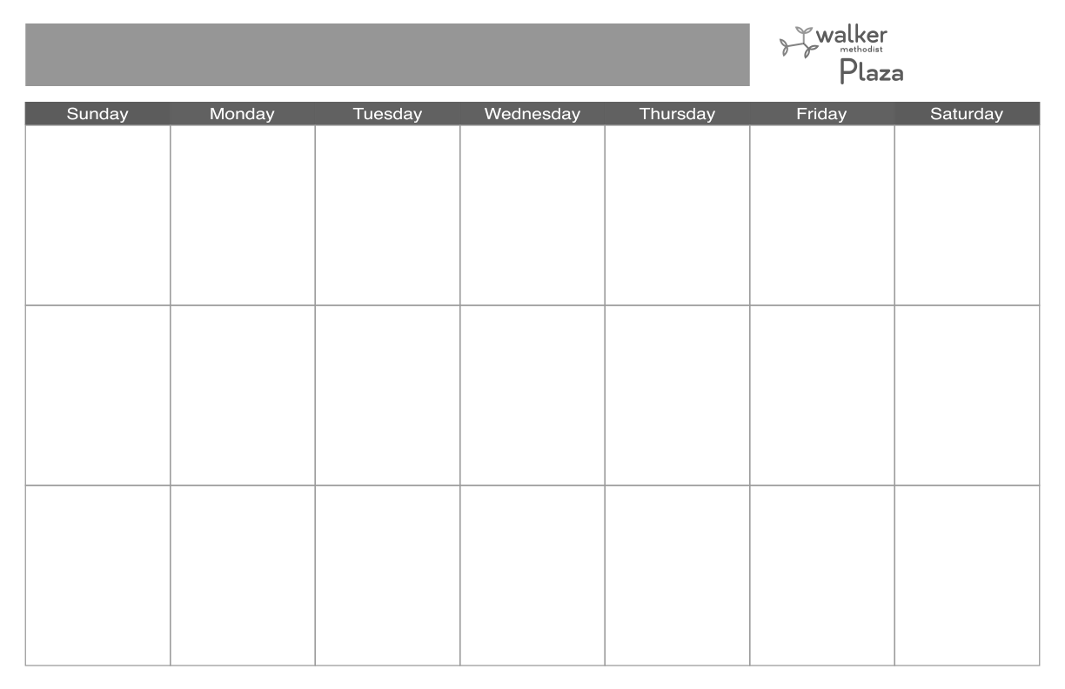 Ball

**20**

**9:30 Mass (CH & 1-3)**

**10:30 Cardio Drumming**

**(RH)**

**1:00 Mobile Activity**

**Cart (TCN)**

**1:00 Crossword**

**3:30 Prize Bingo**

**4:30 Rosary (CH)**

**10**

**9:30 Sing-along with**

**Katherine (LH)**

**10:00 Mobile Activity**

**Cart (LTC)**

**10:30 Fitness with**

**Therapy (LH)**

**11:15 Fitness with**

**Therapy (RH)**

**1:30 Candy Bingo with**

**Sunny (LH)**

**3:00 Discussion Group**

**4:30 Rosary (TV 1-3)**

**17**

**11:00 Mobile Activity**

**Cart (LTC)**

**10:30 Fitness with**

**Therapy (LH)**

**11:15 Fitness with**

**Therapy (RH)**

**1:30 Candy Bingo with**

**Sunny (LH)**

**3:00 Discussion Group**

**4:30 Rosary (TV 1-3)**

**18**

**9:30 Mass (CH)**

**10:15 Stretch & Volley**

**10:30 Library Cart**

**1:30 Armchair Travel:**

**San Francisco**

**3:30 Name the Singer**

**4:30 Rosary (CH)**

**11**

**9:30 Mass (CH)**

**10:15 Stretch & Volley**

**10:30 Library Cart**

**1:30 Music with Pop**

**Standards Social**

**Club (IL DR)**

**1:45 Music with**

**Kristin (LH)**

**3:30 What Am I?**

**4:30 Roasry (CH)**

**13**

**9:30 Mass (CH & 1-3)**

**10:30 Cardio Drumming**

**(RH)**

**1:00 Mobile Activity**

**Cart (TCN)**

**1:00 Dice Game**

**3:30 Prize Bingo**

**4:30 Rosary (CH)**

**6**

**9:30 Mass & Adoration**

**(CH & 1-3)**

**10:30 Cardio Drumming**

**(RH)**

**1:00 Reminiscing with**

**the Senses**

**3:00 Prize Bingo**

**4:30 Rosary (CH)**

**3**

**10:30 Fitness with**

**Therapy (LH)**

**11:00 Mobile Activity**

**Cart (LTC)**

**11:15 Fitness with**

**Therapy (RH)**

**1:30 Candy Bingo with**

**Sunny (LH)**

**3:00 Discussion Group**

**4:30 Rosary (TV 1-3)**

**January 2023 LTC & TCU**

**19**

**10:30 Fitness with**

**Therapy (LH)**

**11:00 Protestant Service**

**(CH)**

**11:00 Mobile Activity**

**Cart (TCU)**

**11:15 Fitness with**

**Therapy (RH)**

**1:30 Music with Rockin**

**Woody (IL DR)**

**2:45 Happy Hour**

**(IL DR & CR)**

**4:30 Rosary (CH)**

**12**

**10:30 Fitness with**

**Therapy (LH)**

**11:00 Protestant Service**

**(CH)**

**11:00 Mobile Activity**

**Cart (TCU)**

**11:15 Fitness with**

**Therapy (RH)**

**2:45 Happy Hour**

**(CR)**

**4:30 Rosary (CH)**

**8**

**10:30 Mass**

**(CH & 1-3)**

**3:30 Afternoon Snacks**

**with NAR’s**

**2**

**10:00 Donuts &**

**Devotions (LH)**

**11:00 Mobile Activity**

**Cart (TCU)**

**1:30 Celebrity Spotlight**

**3:00 Crafternoon’s:**

**Jingle Sticks**

**4:30 Rosary (TV 1-3)**

**7**

**3:00 Snacks with**

**NAR’s**

**4**

**9:30 Mass (CH)**

**10:15 Stretch & Volley**

**10:30 Library Cart**

**1:30 Thunder ball**

**Lottery & Snacks**

**3:00 Name the Singer**

**4:30 Rosary (CH)**

**5**

**10:30 Resident Council**

**11:00 Protestant Service**

**(CH)**

**11:00 Mobile Activity**

**Cart (TCU)**

**1:30 Music with Les**

**Blake (IL DR)**

**2:45 Happy Hour**

**(IL DR & CR)**

**4:30 Rosary (CH)**

**1**

**16**

**10:00 Donuts &**

**Devotions (LH)**

**11:00 Mobile Activity**

**Cart (TCU)**

**1:30 Crafternoon’s:**

**Snowflake**

**3:00 Balloon Volleyball**

**4:30 Rosary (TV 1-3)**

**15**

**10:30 Mass**

**(CH & 1-3)**

**3:30 Afternoon Snacks**

**with NAR’s**

**14**

**3:00 Snacks with**

**NAR’s**

**9**

**10:00 Donuts &**

**Devotions (LH)**

**11:00 Mobile Activity**

**Cart (TCU)**

**1:30 Celebrity Spotlight**

**3:00 Crafternoon’s:**

**Q Tip Trees**

**4:30 Rosary (TV 1-3)**

**21**

**3:00 Snacks with**

**NAR’s**

**25**

**9:30 Mass (CH)**

**10:15 Stretch & Volley**

**10:30 Library Cart**

**1:45 Music with**

**Kristin (LH)**

**3:30 Gem Sun Catchers**

**4:30 Mass (CH)**

**24**

**9:30 Sing-along with**

**Katherine (LH)**

**10:00 Mobile Activity**

**Cart**

**10:30 Fitness with**

**Therapy (LH)**

**11:15 Fitness with**

**Therapy (RH)**

**1:30 Candy Bingo with**

**Sunny (LH)**

**3:00 Discussion Group**

**4:30 Rosary (TV 1-3)**

**27**

**9:30 Mass (CH & 1-3)**

**10:30 Cardio Drumming**

**(RH)**

**1:00 Mobile Activity**

**Cart (TCN)**

**1:00 What Am I?**

**3:30 Prize Bingo**

**4:30 Rosary (CH)**

**January 2023 LTC & TCU**

**31**

**10:30 Fitness with**

**Therapy (LH)**

**11:00 Mobile Activity**

**Cart**

**11:15 Fitness with**

**Therapy (RH)**

**1:30 Candy Bingo with**

**Sunny (LH)**

**4:30 Rosary (TV 1-3)**

**29**

**10:30 Mass**

**(CH & 1-3)**

**3:30 Afternoon Snacks**

**with NAR’s**

**30**

**10:00 Donuts &**

**Devotions (LH)**

**11:00 Mobile Activity**

**Cart (TCU)**

**1:30 Celebrity Spotlight**

**3:00 Crafternoon’s:**

**Salt Paint**

**4:30 Rosary (TV 1-3)**

**23**

**10:00 Donuts &**

**Devotions (LH)**

**11:00 Mobile Activity**

**Cart (TCU)**

**1:30 Crafternoon’s:**

**Snowflakes**

**3:00 IN2L**

**4:30 Rosary (TV 1-3)**

**Program Locations**

**(C) Cinema**

**(CH) Chapel**

**(CR) Club Room**

**(ILDR) IL Dining Room**

**(RH) Roadhouse**

**(LH) Lakehouse**

**(TCN) Transitional Care**

**Neighborhood**

**26**

**10:30 Fitness with**

**Therapy (LH)**

**11:00 Protestant Service**

**(CH)**

**11:00 Mobile Activity**

**Cart (TCU)**

**11:15 Fitness with**

**Therapy (RH)**

**1:30 Music with The**

**Somewhat Jazz**

**Band (IL DR)**

**2:45 Happy Hour**

**(IL DR & CR)**

**4:30 Rosary (CH)**

**Please note all activities are subject to change. Please check daily calendars located throughout the community for changes**

**22**

**10:30 Mass**

**(CH & 1-3)**

**3:30 Afternoon Snacks**

**with NAR’s**

**Activities highlighted in blue are led by Fitness**

**28**

**3:00 Snacks with**

**NAR’s**