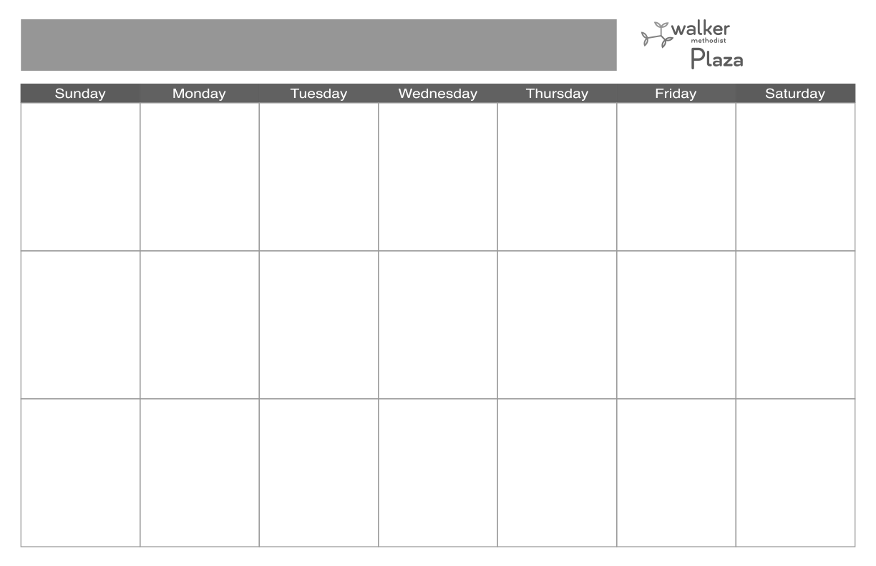usi 

**11**

**8:00 Breakfast**

**9:15 Fitness w/Emma**

**9:30 Mass (TV 1-3)**

**10:15 Good Morning**

**Greetings**

**10:30 Balloon Volleyball**

**12:00 Lunch**

**1:30 Music with Pop**

**Standard Social**

**3:00 Bingo**

**4:00 Mass (CH)**

**5:00 Dinner**

**6**

**8:00 Breakfast**

**9:30 Mass & Adoration**

**(CH)**

**10:15 Good Morning**

**Greetings**

**10:30 Riddle Me This**

**12:00 Lunch**

**1:30 IN2L**

**2:30 Movie Matinee:**

**4:30 Rosary (TV 1-3)**

**5:00 Dinner**

**20**

**8:00 Breakfast**

**9:30 Mass & Adoration**

**(CH)**

**10:15 Good Morning**

**Greetings**

**10:30 Sing-along with**

**Suzie Q**

**12:00 Lunch**

**1:30 IN2L**

**2:30 Movie Matinee:**

**4:30 Rosary (TV 1-3)**

**10**

**8:00 Breakfast**

**10:00 Good Morning**

**Greetings**

**10:15 Cardio Drumming**

**12:00 Lunch**

**1:30 Sing-along with**

**Diane**

**3:00 Crafternoon’s:**

**Q-Tip Painting**

**4:30 Rosary (TV 1-3)**

**5:00 Dinner**

**21**

**7**

**12**

**8:00 Breakfast**

**10:00 Good Morning**

**Greeting**

**10:15 Sit & Be Fit**

**11:00 Protestant Service**

**(CH & TV 1-3)**

**12:00 Lunch**

**1:30 Music (IL DR)**

**2:45 Happy Hour**

**4:30 Rosary (TV 1-3)**

**5:00 Dinner**

**8**

**8:00 Breakfast**

**10:30 Mass (TV 1-3)**

**12:00 Lunch**

**5:00 Dinner**

**5**

**8:00 Breakfast**

**10:00 Good Morning**

**Greeting**

**10:15 Sit & Be Fit**

**11:00 Protestant Service**

**(CH & TV 1-3)**

**12:00 Lunch**

**1:30 Music with Les**

**Blake (IL DR)**

**2:45 Happy Hour**

**4:30 Rosary (TV 1-3)**

**5:00 Dinner**

**2**

**8:00 Breakfast**

**10:00 Good Morning**

**Greetings**

**10:15 Movin’ & Shakin’**

**10:45 T is for Trivia**

**12:00 Lunch**

**1:30 New Year’s Humor**

**& Snacks**

**3:00 Dice Games**

**4:30 Rosary (TV 1-3)**

**5:00 Dinner**

**4**

**8:00 Breakfast**

**9:15 Fitness w/Emma**

**9:30 Mass (TV 1-3)**

**10:15 Good Morning**

**Greetings**

**10:30 Balloon Volleyball**

**12:00 Lunch**

**1:00 Music with Kristin**

**3:00 Prize Bingo**

**4:00 Mass (CH)**

**5:00 Dinner**

**1**

**8:00 Breakfast**

**10:30 Mass (TV 1-3)**

**12:00 Lunch**

**5:00 Dinner**

**13**

**8:00 Breakfast**

**9:30 Mass & Adoration**

**(CH)**

**10:15 Good Morning**

**Greetings**

**10:30 Sing-along with**

**Suzie Q**

**12:00 Lunch**

**1:30 IN2L**

**2:30 Movie Matinee:**

**4:30 Rosary (TV 1-3)**

**3**

**8:00 Breakfast**

**10:00 Good Morning**

**Greetings**

**10:15 Cardio Drumming**

**12:00 Lunch**

**1:30 Sing-along with**

**Diane**

**3:00 Crafternoon’s:**

**Jingle Sticks**

**4:30 Rosary (TV 1-3)**

**5:00 Dinner**

**16**

**8:00 Breakfast**

**10:00 Good Morning**

**Greetings**

**10:15 Movin’ & Shakin**

**10:45 T is for Trivia**

**12:00 Lunch**

**1:30 EZ Yahtzee**

**3:00 Celebrity Spotlight**

**4:30 Rosary (TV 1-3)**

**5:00 Dinner**

**1****9**

**8:00 Breakfast**

**10:00 Good Morning**

**Greeting**

**10:15 Sit & Be Fit**

**11:00 Protestant Service**

**(CH & TV 1-3)**

**12:00 Lunch**

**1:30 Music (IL DR)**

**2:45 Happy Hour**

**4:30 Rosary (TV 1-3)**

**5:00 Dinner**

**17**

**8:00 Breakfast**

**10:00 Good Morning**

**Greetings**

**10:15 Cardio Drumming**

**12:00 Lunch**

**1:30 Sing-along with**

**Diane**

**3:00 Crafternoon’s:**

**Fridge Magnets**

**4:30 Rosary (TV 1-3)**

**5:00 Dinner**

**15**

**8:00 Breakfast**

**10:30 Mass (TV 1-3)**

**12:00 Lunch**

**5:00 Dinner**

**18**

**8:00 Breakfast**

**9:15 Fitness w/Emma**

**9:30 Mass (TV 1-3)**

**10:15 Good Morning**

**Greetings**

**10:30 Balloon Volleyball**

**12:00 Lunch**

**1:00 Music with Kristin**

**3:00 Bingo**

**4:30 Rosary (CH)**

**5:00 Dinner**

**14**

**9**

**8:00 Breakfast**

**10:00 Good Morning**

**Greetings**

**10:15 Movin’ & Shakin**

**10:45 T is for Trivia**

**12:00 Lunch**

**1:30 Gem Suncatcher**

**3:00 Celebrity Spotlight**

**4:30 Rosary (TV 1-3)**

**5:00 Dinner**

**January 2023 Memory Care**

**Community Life Phone Numbers**

**Cindy (Community Life Director) 763-493-7016**

**Amanda (Driver/Rec. Assistant) 763-493-7030**

**Rebecca (Therapeutic Rec. Coordinator) 763-493-7039**

**Jodi (Therapeutic Rec. Coordinator) 763-493-7053**

**29**

**8:00 Breakfast**

**10:30 Mass (TV 1-3)**

**12:00 Lunch**

**5:00 Dinner**

**30**

**8:00 Breakfast**

**10:00 Good Morning**

**Greetings**

**10:15 Movin’ & Shakin**

**10:45 T is for Trivia**

**12:00 Lunch**

**1:30 Candy Bingo**

**3:00 Celebrity Spotlight**

**4:30 Rosary (TV 1-3)**

**5:00 Dinner**

**31**

**8:00 Breakfast**

**10:00 Good Morning**

**Greetings**

**10:15 Cardio Drumming**

**12:00 Lunch**

**1:30 Sing-along with**

**Diane**

**3:00 Crafternoon’s:**

**Suncathcers**

**4:30 Rosary (TV 1-3)**

**5:00 Dinner**

**23**

**8:00 Breakfast**

**10:00 Good Morning**

**Greetings**

**10:15 Movin’ & Shakin**

**10:45 T is for Trivia**

**12:00 Lunch**

**1:30 The Price Was**

**Right**

**3:30 Celebrity Spotlight**

**4:30 Rosary (TV 1-3)**

**5:00 Dinner**

**24**

**8:00 Breakfast**

**10:00 Good Morning**

**Greetings**

**10:15 Cardio Drumming**

**12:00 Lunch**

**1:30 Sing-along with**

**Diane**

**3:00 Crafternoon’s:**

**Bird Feeder’s**

**4:30 Rosary (TV 1-3)**

**5:00 Dinner**

**27**

**8:00 Breakfast**

**9:30 Mass & Adoration**

**(CH)**

**10:15 Good Morning**

**Greetings**

**10:30 Sing-along with**

**Suzie Q**

**12:00 Lunch**

**1:30 IN2L**

**2:30 Movie Matinee:**

**4:30 Rosary (TV 1-3)**

**26**

**8:00 Breakfast**

**10:00 Good Morning**

**Greeting**

**10:15 Sit & Be Fit**

**11:00 Protestant Service**

**(CH & TV 1-3)**

**12:00 Lunch**

**1:30 Music with The**

**Somewhat Jazz**

**Band (IL DR)**

**2:45 Happy Hour (IL DR)**

**4:30 Rosary (TV 1-3)**

**5:00 Dinner**

**Please note all activities are subject to change. Please check daily calendars located throughout the community for changes**

**22**

**8:00 Breakfast**

**10:30 Mass (TV 1-3)**

**12:00 Lunch**

**5:00 Dinner**

**28**

**25**

**8:00 Breakfast**

**9:15 Fitness w/Emma**

**9:30 Mass (TV 1-3)**

**10:15 Good Morning**

**Greetings**

**10:30 Balloon Volleyball**

**12:00 Lunch**

**1:00 Can You Picture**

**This?**

**3:00 Bingo**

**4:00 Mass (CH)**

**5:00 Dinner**

**January 2023 Memory Care**